

University of **Asia Pacific**

#### Database Systems Lab - CSE 212

Partners Name : Nishat Shahrin

**Mst. Nipa Khatun**

Partners ID : 18201084

**18201091**

Section : B2

Project’s Name **: Farm Management System**

Instructor : **Fahad Ahmed**

***Farm Management System***

**Project Objectives :**

*This project presents a farming management system that implements a conceptual framework for buying and selling the production system of agricultural products.*

*In our country, in this pandemic situation everyone is at risk of going out. For this we can see what products of a project are sitting at home. We can easily buy anything from this project, pay money from anywhere. And we can take fresh food very easily. By doing this, we can save a lot of time and ensure the safety for our health.*

**ER-Diagram :**

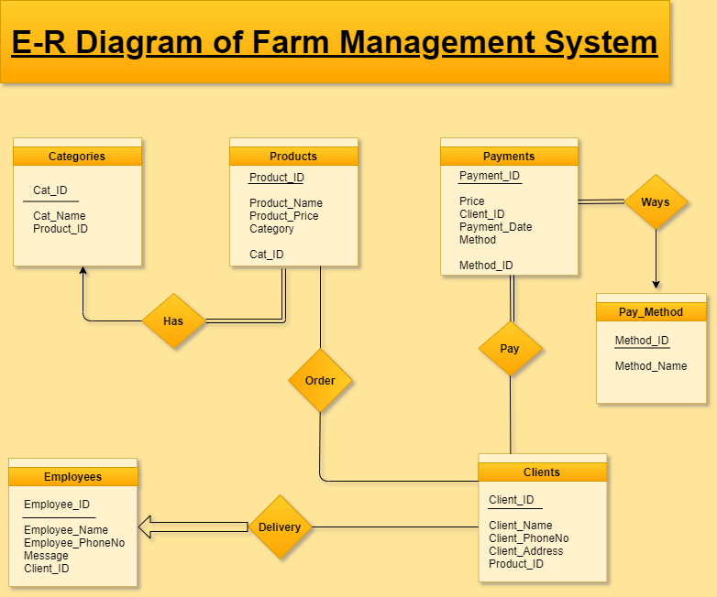

**Questions and Queries :**

**1. What kind of categories has in Product table :**

SELECT p.Product_Name,c.Cat_Name

FROM products AS p,categories AS c

WHERE p.category = c.Cat_ID AND c.Cat_ID = '2';

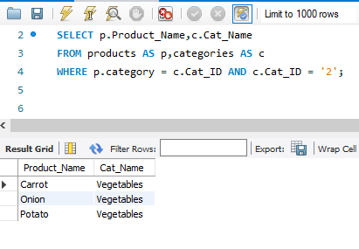

**2. Clients from same Address :**

SELECT Client_ID, Client_Name

FROM clients

WHERE Client_Address = 'Dhaka';

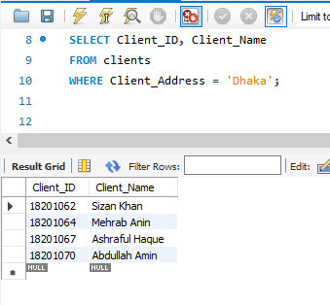

**3. Delivery status :**

select * from employees

where message='done';

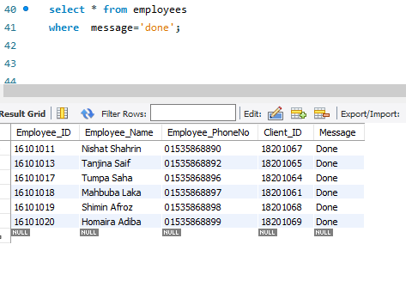

**4. Product details with categories :**

select *FROM products

join categories on Category=Cat_ID;

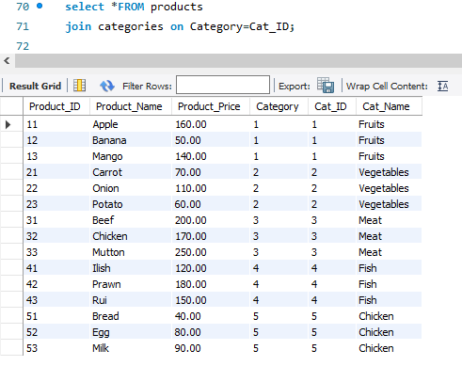

**5. Available products in a specific price :**

SELECT *FROM products

WHERE Product_Price < 100;

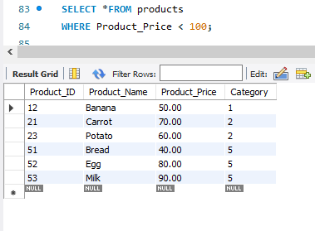

**6. Joining Clients and Products table :**

select *FROM clients

join products using (Product_ID);

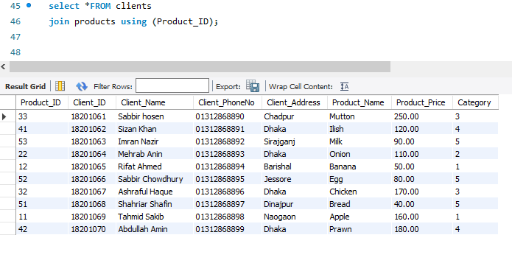

**7. Clients got the product from which Employee :**

SELECT c.Client_Name,e.Employee_Name AS Delivary_Man,p.Product_Name

FROM employees AS e, clients AS c, products AS p

WHERE e.Client_ID = c.Client_ID AND p.Product_ID = c.Product_ID;

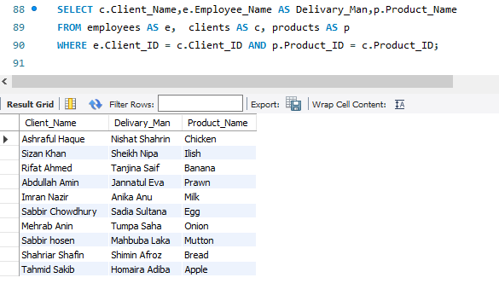

**8. Maximum price of each category :**

SELECT c.Cat_Name,MAX(p.Product_Price) AS MAX_Price

FROM products AS p,categories AS c

WHERE p.Category = c.Cat_ID

GROUP BY c.Cat_ID;

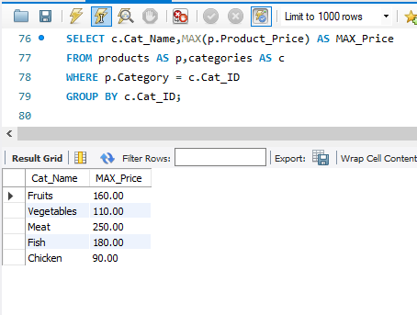

**9. How many products has been taken a client :**

Select Client_Name ,COUNT(Product_ID) AS 'Number of Product buy'

FROM clients

join products using (Product_ID)

Group by Client_Name;

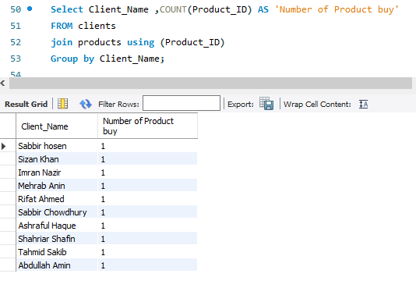

**10.Which client ordered the product on a specific date :**

Select Client_Name ,Client_Address,Client_PhoneNo, Product_Name,Product_Price

FROM clients

join products using (Product_ID)

WHERE Client_ID IN (select Client_ID FROM Payments

WHERE Payment_Date ='2020.09.15' );

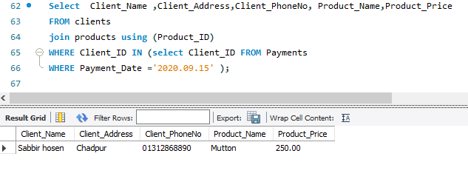

**11. Add vat with total price :**

SELECT c.Client_Name,p.Price,(p.Price + p.Price*.15) AS 'VAT with Price',pm.Method_Name

FROM payments AS p,clients AS c,pay_method AS pm

WHERE p.Client_ID = c.Client_ID AND pm.Method_ID = p.Method AND p.price=p.price;

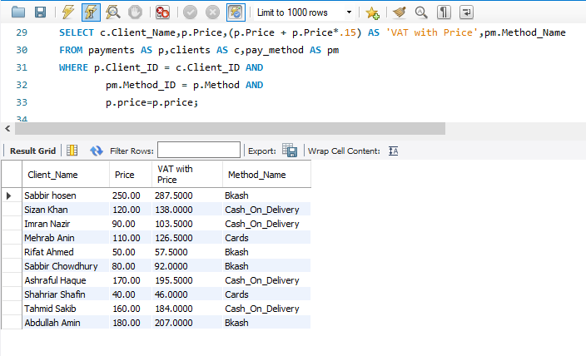

**12. Clients brought products from which category :**

SELECT c.Client_ID,c.Client_name,p.Product_ID,p.Product_Name,ct.Cat_Name

FROM clients AS c,products AS p,categories AS ct

WHERE c.Product_ID = p.Product_ID AND p.category = ct.cat_id AND

p.Product_ID = c.Product_ID;

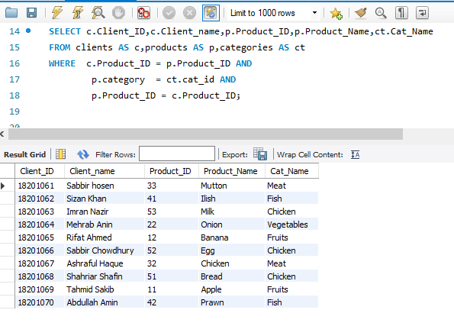

**13. Average price of each category :**

SELECT c.Cat_Name,AVG(p.Product_Price) AS 'Categories AVG Price'

FROM products AS p,categories AS c

WHERE p.category = c.Cat_ID

GROUP BY c.Cat_ID;

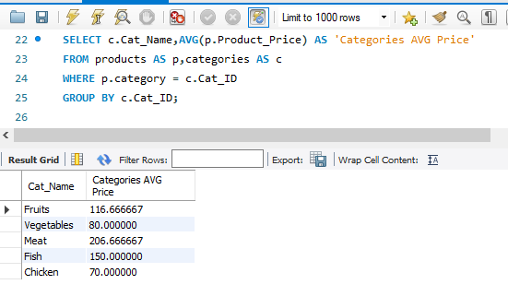

**14. Which client pay in which Method :**

SELECT c.Client_Name,p.Product_Name,pay.Price,pm.Method_Name

FROM clients AS c,products AS p,payments AS pay,pay_method AS pm

WHERE c.Client_ID = pay.Client_ID AND p.Product_ID = c.Product_ID AND pay.Method = pm.Method_ID AND pm.Method_ID

IN (SELECT pm.Method_ID

FROM pay_method

WHERE Method = 123);

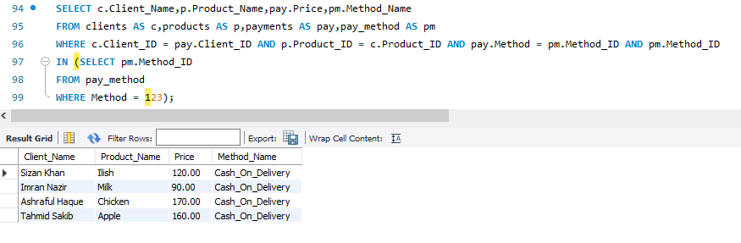

**15. Full information of a single client :**

SELECT c.Client_Name,p.Product_Name,pay.Price,pay.Payment_Date,pm.Method_Name,e.Employee_Name

FROM clients AS c,products AS p,payments AS pay,pay_method AS pm,employees AS e

WHERE e.Client_ID = c.Client_ID AND c.Client_ID = pay.Client_ID AND p.Product_ID = c.Product_ID AND

pay.Method = pm.Method_ID AND c.Client_ID = '18201067';

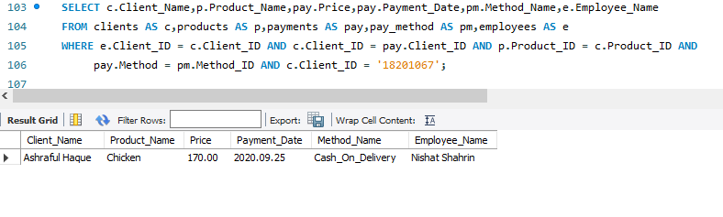

**Conclusion :**

*Now a days, we know that online marketing system is making a large position in our economic status . But the problem is, when we want to buy a product, we don't really understand what type of products or categories are there, is it hygienic or not,what is the price and how much we can buy. In our daily life, we need some essential products or food. But sometimes, these things were not hygienic outside.That’s why this type of management projects are become helpful for our daily life. All the information can be seen by the buyers. So they can easily buy any products . Also it can save our time.*